Jomar Pueyo UXT302

Location: /home/UTSARR/uxt302/Lab8/

LAB 8: Floating Point Multiplier

Waveform:

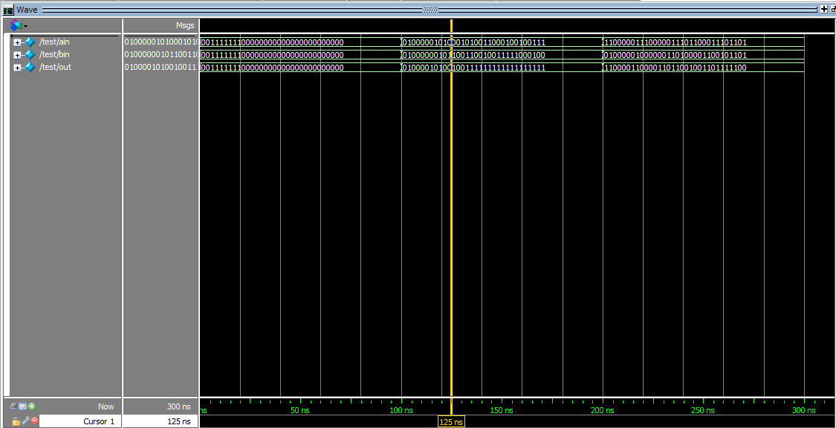

Chip Layout:

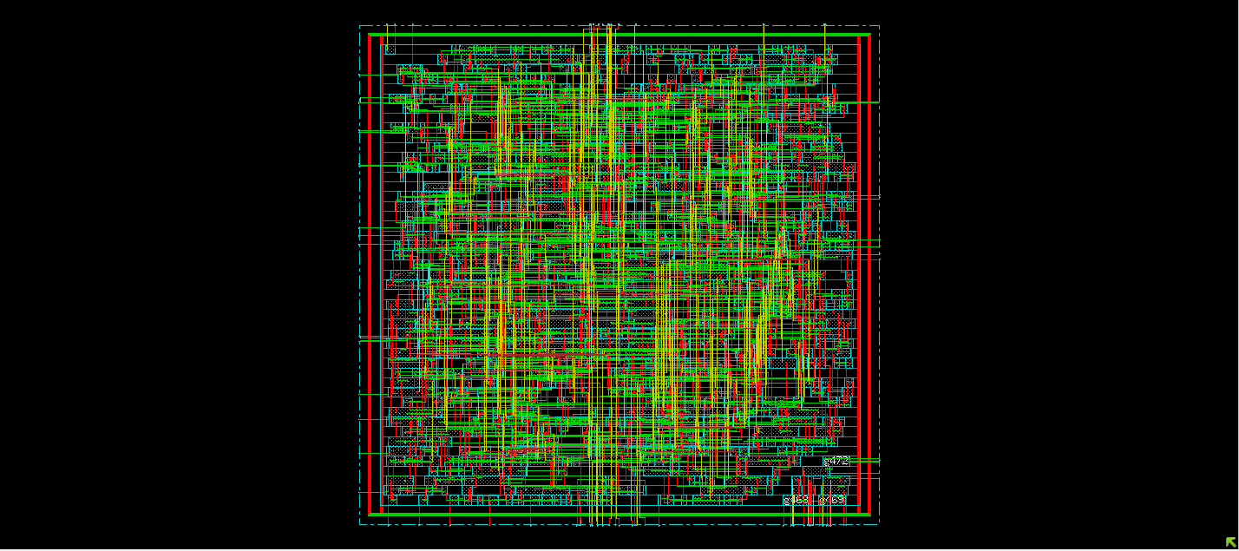

Verify DRC:

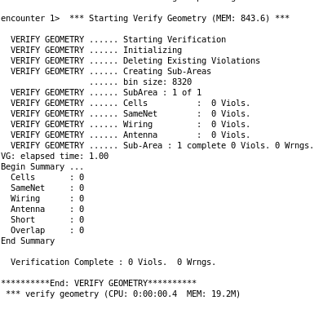

Verify Connectivity:

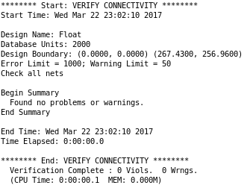

Schematic:

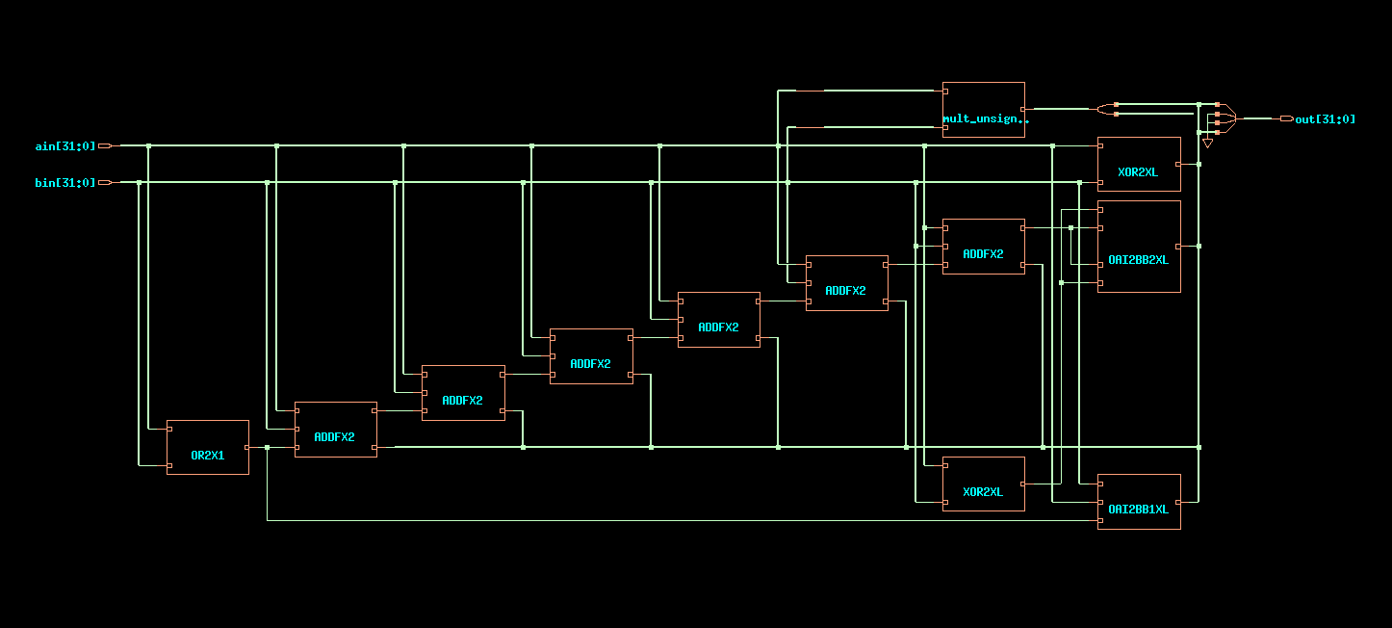

GDS “Streamout is successful”:

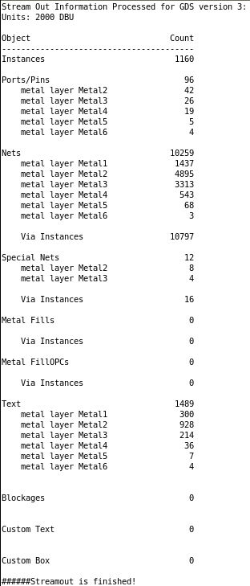

**Table:**

|  |  |
| --- | --- |
| **Area** | |
| Total cells used in design | 46 |
| Cell area | 875 |
| **Pre-Route** | |
| CPU Time | 0.35 sec |
| Memory Usage | 792.594 Mbytes |
| **Post-Route** | |
| CPU Time | 0.28 sec |
| Memory Usage | 806.473 Mbytes |

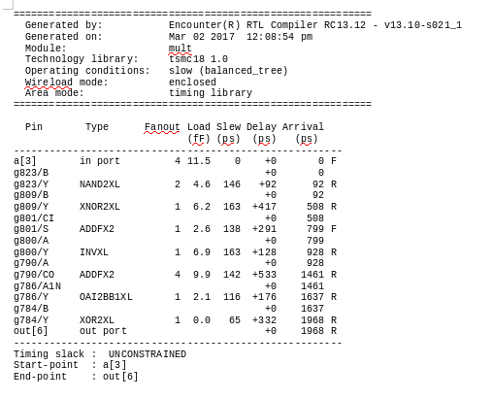

E:\VLSI\Lab Assignment 8\Pre-Timings.PNG

